**Android Lab Cycle 2**

1. Design a Login Form with username and password using LinearLayout and toast valid credentials
2. Create an application to design a Visiting Card. The Visiting card should have a company logo at the top right corner. The company name should be displayed in Capital letters, aligned to the centre. Information like the name of the employee, job title, phone number, address, email, fax and the website address is to be displayed. Insert a horizontal line between the job title and the phone number.

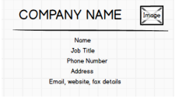

1. Develop an Android application using controls like Button, TextView, EditText for designing a calculator having basic functionality like Addition, Subtraction, Multiplication, and Division.

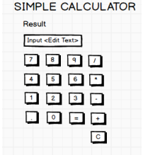

**package** com.example.lifecycle;

**import** androidx.appcompat.app.AppCompatActivity;

**import** android.os.Bundle;

**import** android.util.Log;

**public class** MainActivity **extends** AppCompatActivity {

@Override

**protected void** onCreate(Bundle savedInstanceState) {

**super**.onCreate(savedInstanceState);

setContentView(R.layout.***activity_main***);

Log.*d*(**"lifecycle"**,**"onCreate invoked"**);

}

@Override

**protected void** onStart() {

**super**.onStart();

Log.*d*(**"lifecycle"**,**"onStart invoked"**);

}

@Override

**protected void** onResume() {

**super**.onResume();

Log.*d*(**"lifecycle"**,**"onResume invoked"**);

}

@Override

**protected void** onPause() {

**super**.onPause();

Log.*d*(**"lifecycle"**,**"onPause invoked"**);

}

@Override

**protected void** onStop() {

**super**.onStop();

Log.*d*(**"lifecycle"**,**"onStop invoked"**);

}

@Override

**protected void** onRestart() {

**super**.onRestart();

Log.*d*(**"lifecycle"**,**"onRestart invoked"**);

}

@Override

**protected void** onDestroy() {

**super**.onDestroy();

Log.*d*(**"lifecycle"**,**"onDestroy invoked"**);

}

}

